**Name : Raksha**

**Batch11**

**Date : 18/7/25**

**Terraform class2- tasks**

**Question 1**

**1.make a mistake in configration -> run validate -> correct and execute**

Created one directory first name Raksha-> inside that one more directory created 1807-> created one file file.tf

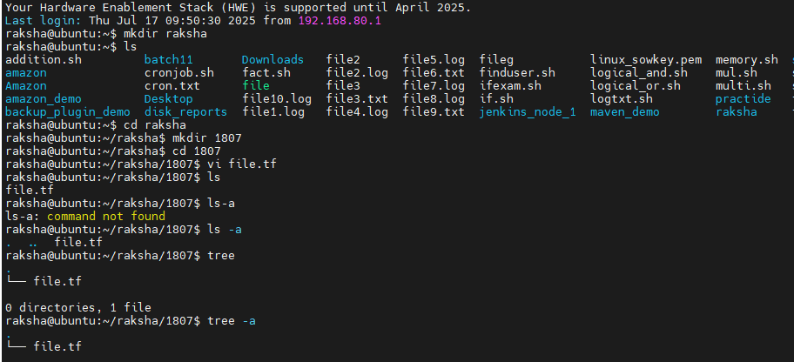

Write resources like below

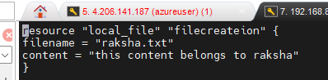

Error I did here “file name” instead of “filename”

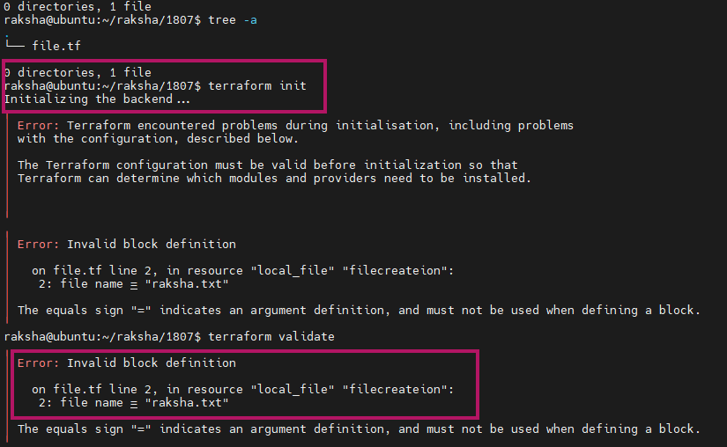

Terraform initialize after error correction

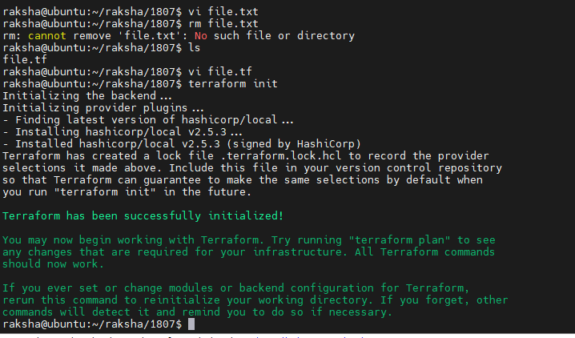

Terraform plan-> it is diplaying file name, content of the file also

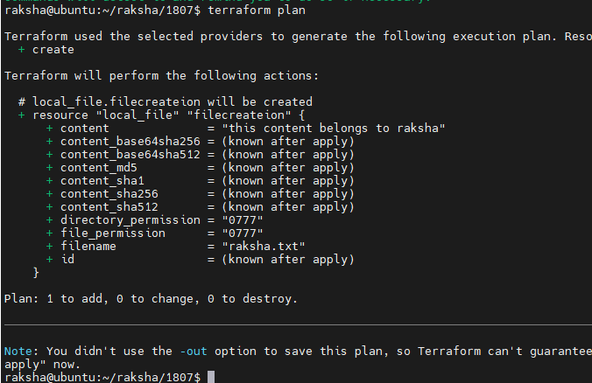

Terraform apply-> ls-> Raksha.txt

Cat raksha.txt-> this cotent belongs to Raksha msg displayed

